20164332 Kwanggun

GCT722 Topics in Virtual Reality: Mathematical Method for Visual Computing

EXCERISE 4

< GRAPH CUT >

TASK 1

Using max-flow algorithm we can segment the following graph into two parts.

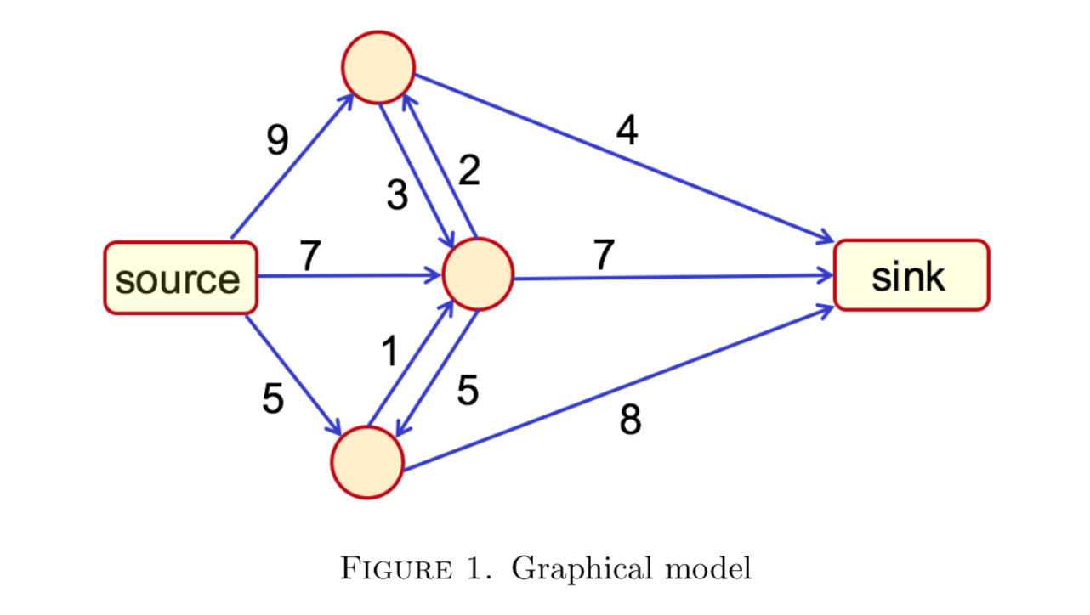

|  |  |
| --- | --- |
| /Users/edwardseo/Downloads/KakaoTalk_2017-12-04-21-14-25_Photo_52.jpeg | /Users/edwardseo/Downloads/KakaoTalk_2017-12-04-21-14-26_Photo_71.jpeg |
| Figure 2. First iteration of Graph Cut | Figure 3. Segmented result of figure 1 |

|  |
| --- |
| /Users/edwardseo/Desktop/Screen Shot 2017-12-04 at 9.13.26 PM.png |
| Figure 4. Graph Cut code for figure 1 |
| /Users/edwardseo/Desktop/Screen Shot 2017-12-04 at 9.17.17 PM.png |
| Figure 5. Result of figure 4 code |

As seen in the figure 3 and 5 the results match. However the label is switched which might be due to the labeling difference of the code.

TASK 2

The following figures show the result of the segmented image using marked data.

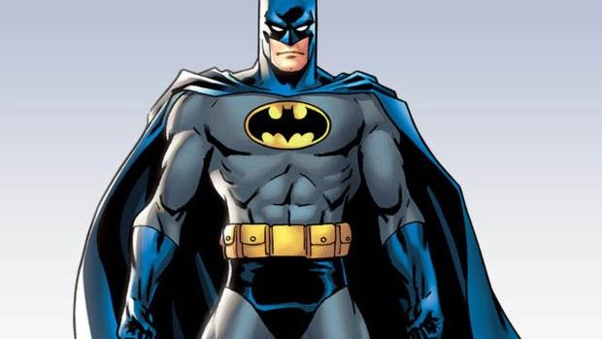

Figure 6. Batman Original

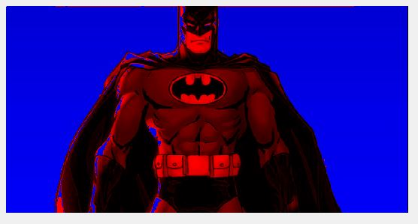

Figure 8. Batman segmented Result with

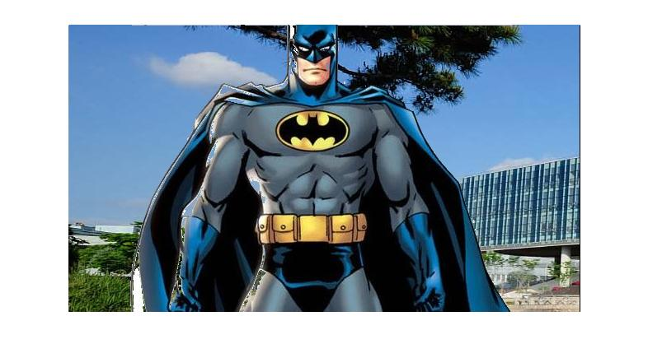

Figure 10. Batman with different background with

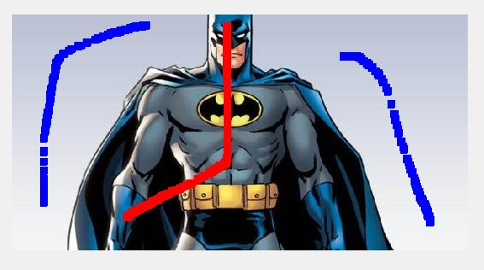

Figure 7. Batman Scribble

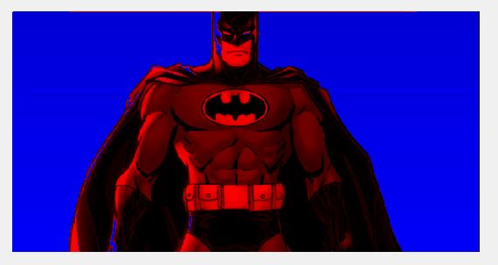

Figure 9. Batman segmented Result with

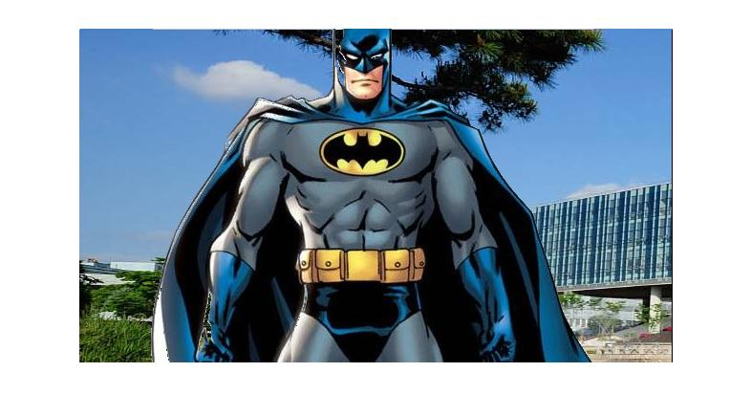

Figure 11. Batman with different background with

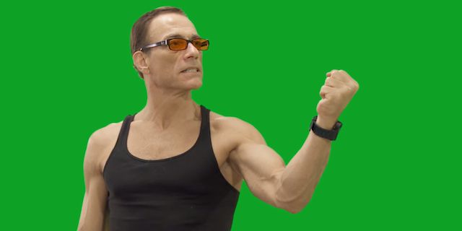

Figure 12. Van Damme Original

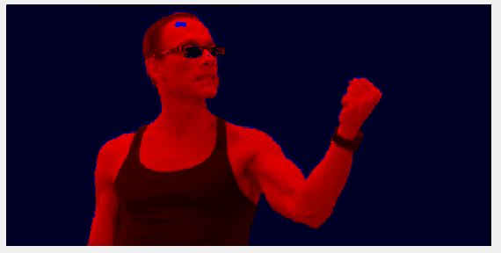

Figure 14. Van Damme segmented Result with

Figure 16. Van Damme segmented Result with

Figure 13. Van Damme with scribble

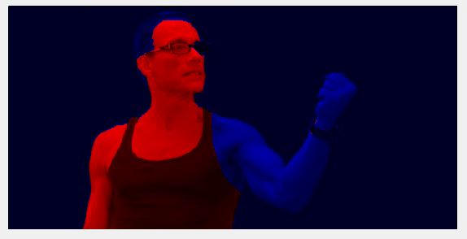

Figure 15. Van Damme with different background with 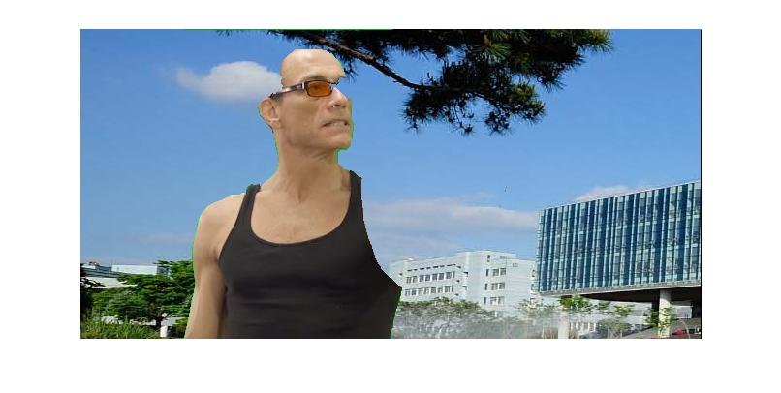

Figure 17. Van Damme with different background with

**Van Damme with my own background**

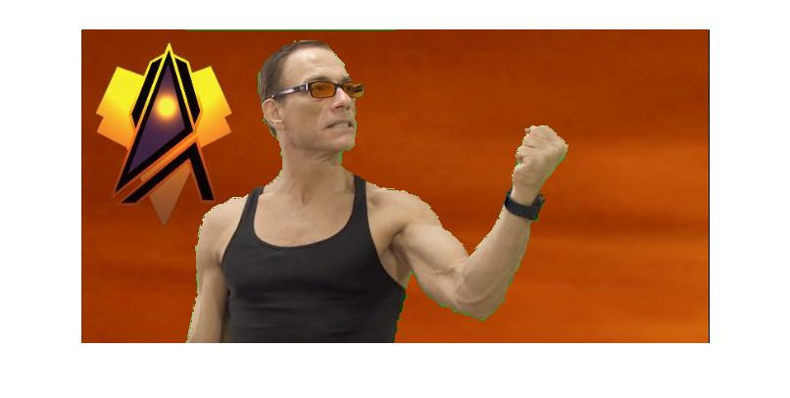

Figure 18. Van Damme segmented Result with

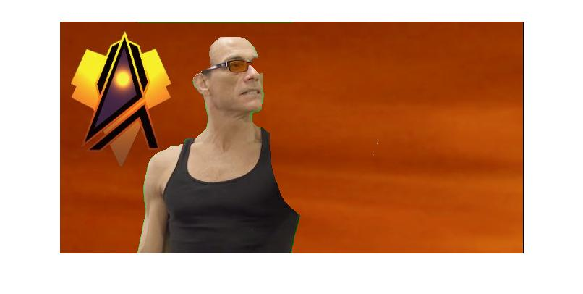

Figure 19. Van Damme segmented Result with

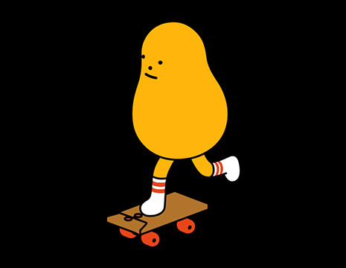

Figure20. Original Image

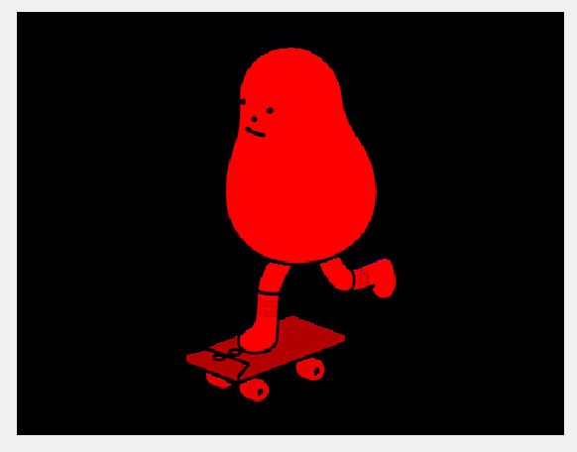

Figure 22. Image segmented with

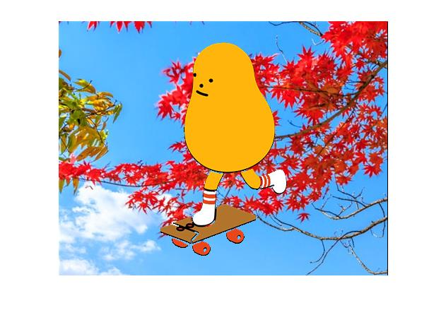

Figure 24. Image with background with

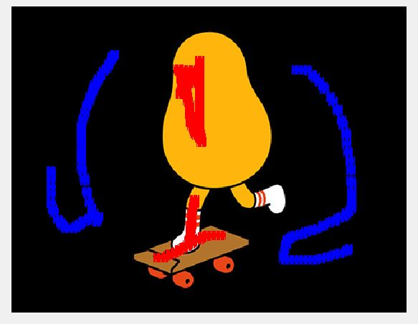

Figure 21. Image with scribble

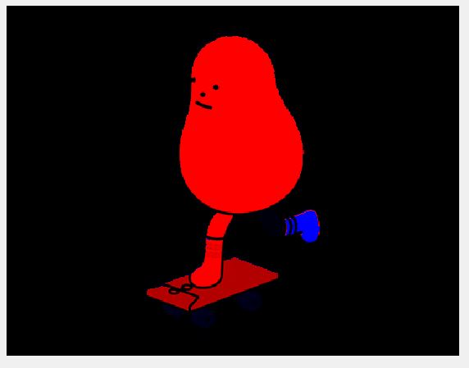Figure 23. Image segmented with

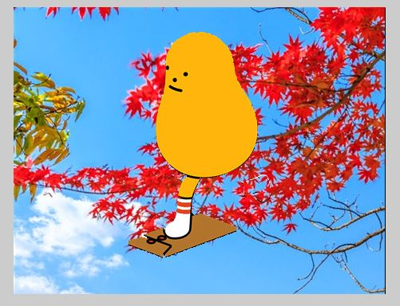

Figure 25. Image with background with